



|  |  |
| --- | --- |
| **Baltic Training Services** | **Level 3: Project Management** |

**Assignment Template**

|  |  |  |  |
| --- | --- | --- | --- |
| Candidate Name: | Alex Duxfield | Date Submitted: |  |
| Trainer Name: | Andy Brown |  |  |

|  |
| --- |
| **Level 3: Project Management**| **v2.0** |

Outcome 1

Below the image indicate the type of project management structure and detail the key features of this structure

1.1

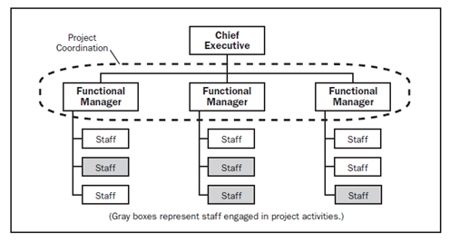

|  |  |
| --- | --- |
| Name | Functional structure |
| Key Features | Hierarchical  Specialist manager  Project manager  Coordinates |

1.2.

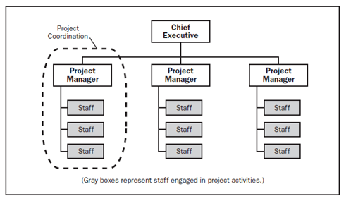

|  |  |
| --- | --- |
| Name | Projectized |
| Key Features | Line manager  Set work priorities  Staff reassigned at close |

1.3

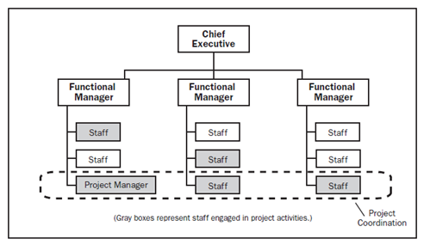

|  |  |
| --- | --- |
| Name | Matrix |
| Key Features | Project/function manager  Share responsibility  Function manger –technical  Project manager – coordinates |

Outcome 2

2.1 Review the list of items. Categorize each as a Risk or Opportunity

|  |  |  |  |
| --- | --- | --- | --- |
| Item | Risk/Opportunity | Likelihood | Impact |
| Different stakeholders fail to agree on scope | risk | 2 | 2 |
| Team members have no experience of new technology being used | risk | 3 | 4 |
| Technology specialist has finished other project early and can be brought on to this task | Opportunity | 2 | 1 |
| Poor sales in Q4 could lead to project budget being reduced | risk | 4 | 5 |
| Good Sales in Q4 could lead to additional funds being available | Opportunity | 2 | 2 |
| Key team members leave before the project is finished | Risk | 1 | 4 |

2.2 Add another typical project risk to the register

|  |  |  |  |
| --- | --- | --- | --- |
| Item | Risk/Opportunity | Likelihood | Impact |
| Budget not used | opportunity | 1 | 1 |

2.3 Input all the risks into the Risk register document. Attach the completed file below



2.4 Based on the risks write a paragraph highlighting the risk exposure. This will be presented to the board

|  |
| --- |
| To take into account of the risk exposure. This can be quite high depending on the risk involved.  **Different stakeholders fail to agree on scope** this is a high risk if this situation occurred. This would mean a late start on the project.  **Team members have no experience of new technology being used**. If this happened then team members would require training this would impact on the start of the project until the training has been completed.  **Technology specialist has finished other project early and can be brought on to this task**  This would be a great opportunity for the project to start early. This would be beneficial as a highly skilled member would make the project on time.  **Poor sales in Q4 could lead to project budget being reduced**  With the budget reduced this would mean that substandard software and hardware might be used. With poor sales this might terminate the project.  **Good Sales in Q4 could lead to additional funds being available**  With additional funds this would mean that the project could start early by employing more people for the job. More funds could lead to better quality Software/hardware. The project could finish early because of good sales.  **Key team members leave before the project is finished**  If key team members leave before the project is finished then the project would be behind time and could even lead to the project being cancelled. The project could even stop until other team members are trained to a standard for carrying on the job.  **Budget not used**  If the budget was not used on the current project then the available funds could be used for a new project or even finish the current project early. By training new staff with the funds. |

Outcome 3

3.1. To ensure quality, list a method you could use to measure the following

|  |  |
| --- | --- |
| Quality | Method |
| Service desk performance | Survey |
| Computer hardware reliability | Audit |
| Label printing speed | Testing |
| Software compatibility | Test requirements of os |

3.2. You are managing a project which will create bespoke labeling software the quality standards for this project are listed below:

Required Standards:

Software must be

1. compatible with windows 7
2. compatible with Lexmark 1000 printers
3. capable of printing 500 labels per min

You have a team of 2 qualified auditors at your disposal.

Using this information and the quality plan template complete the quality plan.

Attach completed plan below



3.3 Review the Supplier tenders, based on the criteria provided, recommend one

*Requirements:*

*Provide 50 Laptop PCS*

*Budget circa £1500*

*OS: WIN 8 Pro*

*Equipment reliability factor >10*

*Company must be ISO 9001 registered*

*Equipment available for delivery before 1st March*

*Support: 3 years extended*

|  |
| --- |
| UKE |

3.4 . for each of the rejected indicate why

|  |
| --- |
| ACB ltd is too expensive.  Alpha is win xp pro only.  Megabytes is not ISO 9001 certified .  Win Computing has only one year guarantee. |

3.5 Review the provided change requests (CR01,CR02,CR03) decide on the appropriate next steps

|  |  |
| --- | --- |
| Request | Recommended next steps |
| CR1 | No as date on cr01 says asap this gives a non-specified date on when to do the work |
| CR2 | As this day is a national recognized day this would be approved as plenty of notice given on the change request form for this event. |
| CR3 | Approved as the date required is good and there is no high risks involved and minimal downtime will be low. |

3.6. Devise a suitable configuration record log. Provide typical values for a Project Business plan and 3 other typical project files**:**



<Attach record here>

Outcome 4

4.1. Identify 4 communications required during a typical project for each identify a suitable method

|  |  |
| --- | --- |
| Communication Required | Method |
| Project manager briefs team on change | Team meeting |
| Contact supplier | e-mail |
| Stake holder Business | Telephone |
| Stakeholder Supplier | e-mail |

Outcome 5

Behaviors

5.1. List the stages of team development and describe the characteristic behaviors

|  |  |
| --- | --- |
| Stage | Characteristic Behaviors |
| Forming (Affiliation) | They forming stage of the team with regards to the Tuchman Model . The person at the start would be polite and very impersonal. They would be watchful and guarded with a very tentative interaction with others in the team. |
| Storming (power) | The Storming stage of the team would have the person who is very confrontational The would be open to conflict within the team and opt out of tasks at any opportunity. They would have difficulties within the team . Often feeling stuck. |
| Norming (Achievement) | The Norming stage would be all about achievement. The person would establish procedures and have no problems giving feedback as well as receiving feedback. They can cope with issues well and develop their skills to a high standard. |
| Performing (synergy) | The performing stage would have the individual very flexible and resourceful they would be open and very effective at what they do. They are supportive to others and is very satisfied in their job. |

5.2. Describe desirable characteristics in terms of skill and behavior for a team leader

|  |
| --- |
| A team leader is very motivated and trustworthy to keep the team on task. They are approachable and can listen to any issues within the team. They have a lot of commitment within the team. A team leader is enthusiastic about the project and can listen to the teams concerns if any arises. They are the go to person in the project if a problem arises. They are very quick thinkers and can use that for any trouble shooting within the team. |

5.3 Characterise the nine Belbin types

|  |  |
| --- | --- |
| Type | Character |
| Plant | The role of the plant is they are an ideas generator. They are creative and unorthodox. Also they are free thinking and may ignore detail in favour of the big picture if there are too many plants then it may stall the project. They have a constant flow of ideas. |
| Monitor evaluator | These people are very objective observers and good at taking broad views. They are good at seeing opportunities and can analyze thoroughly all suggestion evaluation fairly. They may be perceived as negative when critically evaluating. They may be slow to make decisions until all the facts are in. |
| Co-ordinator | The co-ordinator is very calm and confident. They are good at seeing the big picture and are often good team leaders. The coordinator can control and organize effectively within the team. They can motivate and ensure the team is focused on the end goal. |
| Resource Investigator | The resource investigator is very outward looking and focused on opportunities and contacts. They are relaxed and can have an enquiring mind. The resource investigator can see possibilities in many places but may lose focus especially towards the project end. |
| Implementer | The role of the Implementer is that they are self-disciplined and reliable they are the doers in the team. They take tasks and turn them into action. They display common sense and are motivated by loyalty. If implementers don’t believe in ideas they may be perceived as obstructive. |
| Complete Finisher | The complete –finisher is a perfectionist and is has a very attention to detail. They can complete tasks to perfection setting own high standards. The complete-finishers may find it difficult to delegate within the team Which may hinder the project . |
| Team worker | The Teamworker is a very sociable individual and is sensitive towards the team. The hold the teams together and are great listeners within the team. Team workers’ pay great attention to how others perform. They are diplomatic but may be reluctant to take sides within the team and might not make decisions to help the conflict. |
| Shaper | The shaper is sharply focused on one individual task. They exhibit a lot of energy within the team. They are very tenacious in achieving goals and can strive to win as they feel this is important. They are the extrovert people of the team and can be overbearing if managers don’t ensure this. However they can be perceived as blunt and irritable. |
| Specialist | The specialist is a subject matter expert. They are the font of all knowledge but are willing to learn knowledge about their own specialism. However they may not contribute beyond their own specialist field. |

Outcome 7

7.1. Prepare a Product breakdown structure for an office relocation project.



7.2. Prepare a Work Breakdown Structure of an office relocation Project



7.3. Based on the information below create an activity on node network

|  |  |  |
| --- | --- | --- |
| Activity | Duration Days | Dependency |
| A | 10 | None |
| B | 3 | End A |
| C | 4 | End A |
| D | 5 | End C |
| E | 2 | End D |
| F | 1 | End B and End E |

Attach 

7.4. Based on the provided file complete milestone slippage chart

7.5. Interpret and extrapolate earned value figures, look at the below chart is the project on track at week 8? explain how you came to your conclusion

[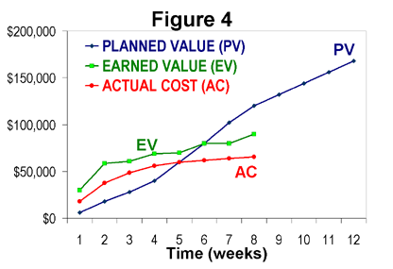](http://upload.wikimedia.org/wikipedia/en/b/b8/EVM_Fig4.png)

|  |
| --- |
| The chart shows that the project is not on track as the earned value for week 8 is lower than the original planned value. |

**END OF ASSIGNMENT**

**Please check through your work thoroughly before submitting.**